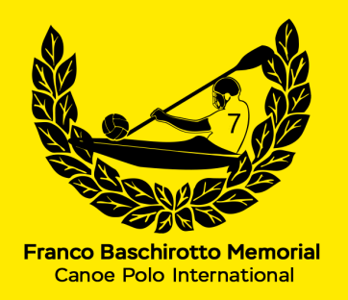 | TEAM/CLUB REGISTRATION  36° FRANCO BASCHIROTTO MEMORIAL 2027  Castello di Porpetto (UD) Italy  10-11 July 2027  ORGANISED BY NATISONE KAYAK CLUB Manzano & KAYAK FIUME CORNO Castello

TEAM INFORMATION
TEAM NAME:
nome SQUADRA:
TRAINER/CAPTAIN:
persona RESPONSABILE:
CONTACT PHONE NUMBER:
numero CONTATTO:
E-MAIL:
indirizzo e-mail:
PLAYING DIVISION:  mark with ‘X’ in the chosen division  segnare il divisione scelta con un ‘X’ | DIVISION 1 | DIVISION 3
Registration Fee € 150 (euro one hundred and fifty) per team.
Please fill out and return this form with proof of payment within the 30th June 2027 to guarantee your place in the Tournament to:
fbm.challengetrophy@gmail.com

Thank you.

