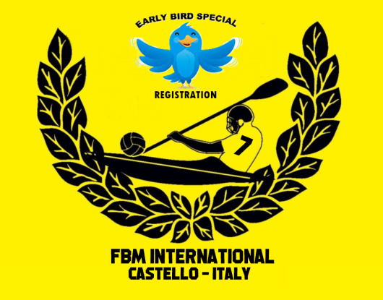 | ‘EARLY BIRD’ REGISTRATION FORM  (VALID FROM 1ST FEBRUARY – 28 FEBRUARY 2026)  35° FRANCO BASCHIROTTO MEMORIAL INTERNATIONAL 2026  Castello di Porpetto (UD) Italy  11 - 12 July 2026  ORGANISED BY NATISONE KAYAK CLUB Manzano & KAYAK FIUME CORNO Castello

TEAM INFORMATION
TEAM NAME:
nome SQUADRA:
PERSON RESPONSABLE:
persona RESPONSABILE:
CONTACT PHONE NUMBER:
numero CONTATTO:
E-MAIL:
indirizzo e-mail:
PLAYING DIVISION:  mark with ‘X’ in the chosen division  segnare il divisione scelta con un ‘X’ | Division I  Elite, FBM Trophy | Division II  Ladies, Minin Cup Trophy
 | Division III  Recreational | Division IV  U18 Juniors
‘EARLY BIRD’ REGISTRATION FEE: € 100 (one hundred euro) for each team in all divisions

Payment is to be made to:
A.S.D. KAYAK FIUME CORNO
IBAN IT 90 R 07085 63890 006210025822
BIC CODE CCRTIT2TK00

Please specify on payment receipt the name of your team(s) and playing division(s).
Proof of payment fees and the return of the form must be sent back within 28th February 2026 to fbm.challengetrophy@gmail.com to guarantee your discounted registration in the Tournament.
Thank you.

