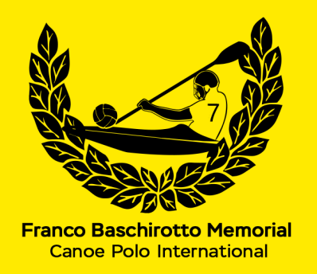 | TEAM REGISTRATION FORM  35° FRANCO BASCHIROTTO MEMORIAL INTERNATIONAL 2026  Castello di Porpetto (UD) Italy  11 - 12 July 2026  ORGANISED BY NATISONE KAYAK CLUB Manzano & KAYAK FIUME CORNO Castello

TEAM INFORMATION
TEAM NAME:
nome SQUADRA:
PERSON RESPONSABLE:
persona RESPONSABILE:
CONTACT PHONE NUMBER:
numero CONTATTO:
E-MAIL:
indirizzo e-mail:
PLAYING DIVISION:  mark with ‘X’ in the chosen division  segnare il divisione scelta con un ‘X’ | Division I  FULL/CLOSED | Division II  Ladies, Minin Cup Trophy
 | Division III  Recreational | Division IV  U18 Juniors
REGISTRATION FEE: € 120 for each team in all divisions
Payment is to be made to:
A.S.D. KAYAK FIUME CORNO
IBAN IT33C0708563890000000025822
BIC: ICRAITRRU50
BANK: CREDITO COOPERATIVO FRIULI
33050 GONARS ITALY
BRANCH NUMBER: 63890

Please specify on payment receipt the name of your team(s) and playing division(s).
Proof of payment fees and the return of the form must be sent back within 30th June 2026 to fbm.challengetrophy@gmail.com to guarantee your participation in the Tournament.
Thank you.

