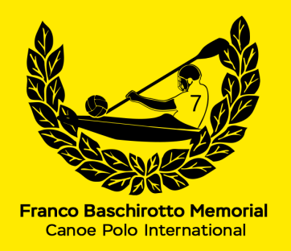 | TEAM/CLUB REGISTRATION  18° MININ CUP LADIES INTERNATIONAL 2027  Castello di Porpetto (UD) Italy  10-11 July 2027  ORGANISED BY NATISONE KAYAK CLUB Manzano & KAYAK FIUME CORNO Castello

TEAM INFORMATION
TEAM NAME:
nome SQUADRA:
TRAINER/CAPTAIN:
persona RESPONSABILE:
CONTACT PHONE NUMBER:
numero CONTATTO:
E-MAIL:
indirizzo e-mail:
Please fill out and return this form with proof of payment within the 30th June 2027 to guarantee your place in the Tournament to:
fbm.challengetrophy@gmail.com

Thank you.

