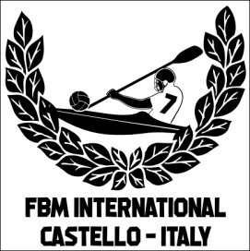 | TEAM DETAILS FORM  35° FRANCO BASCHIROTTO MEMORIAL INTERNATIONAL 2026  Castello di Porpetto (UD) Italy  11 - 12 July 2026  ORGANISED BY NATISONE KAYAK CLUB Manzano & KAYAK FIUME CORNO Castello

TEAM INFORMATION
TEAM NAME:
nome SQUADRA:
TRAINER/CAPTAIN:
persona RESPONSABILE:
CONTACT PHONE NUMBER:
numero CONTATTO:
E-MAIL:
indirizzo e-mail:
PLAYING DIVISION:  mark with ‘X’ in the chosen division  segnare il divisione scelta con un ‘X’ |  |  |  | Division I  Elite, FBM Trophy |  |  | Division II  Ladies, Minin Cup Trophy
 |  |  |  | Division III  Recreational |  |  | Division IV  U18 Juniors
ATHLETES TEAM DETAILS
No. | VEST # |  | FIRST NAME |  | LAST NAME |  |  |  | DATE OF BIRTH  (Only for U18 athletes)
1
2
3
4
5
6
7
8
9
10
REFEREES
 |  | FIRST NAME |  |  |  | LAST NAME |  | NATIONAL REFEREE LEVEL
1ST
2ND
PLUS THREE PEOPLE FROM YOUR CLUB FOR TABLE PROTOCOL DUTIES
(CHRONOMETER TIME-KEEPER/SHOT-CLOCK TIME-KEEPER/SCORECARD OFFICIAL)
N.B. If unable to provide the two referees a compensation fee of € 100 has to paid in advance together with the registration to cover costs of providing alternative game officials.
Please fill out and return this form within the 11th July 2026 to fbm.challengetrophy@gmail.com Thank you.

